

KCA UNIVERSITY

BACHELORS IN DATASCIENCE

BDS 4105 :FINAL YEAR PROJECT 1.

21/04428 NJOROGE HALDLINE MUKAMI

SUPERVISOR: GLADYS MANGE

PROJECT TITLE : MAIZE CROP YIELD PREDICTION AND ADVISORY SYSTEM .

**Declaration of Originality**  
I declare that this project proposal is my original work and has not been submitted to any other institution or examination body. All sources used or quoted have been duly acknowledged.

**Signed:** ____________________  
**Date:** ____________________

**Software Requirements Specification (SRS)**

**Table of Contents**

****Introduction ............................................................................................................... 1  
 1.1 Purpose ......................................................................................................................... 1  
 1.2 Intended Audience and Reading Suggestions ............................................................ 1  
 1.3 Project Scope ................................................................................................................. 2****

****Overall Description ..................................................................................................... 4  
 2.1 Product Perspective ...................................................................................................... 4  
 2.2 Product Features ........................................................................................................... 6  
 2.3 User Classes and Characteristics ................................................................................. 9  
 2.4 Operating Environment ............................................................................................... 12  
 2.5 Design and Implementation Constraints .................................................................... 17****

****System Features ......................................................................................................... 20  
 3.1 Yield Prediction Feature .............................................................................................. 20  
  3.1.1 Description .............................................................................................................. 20  
  3.1.2 Functional Requirements ........................................................................................ 21  
  3.1.3 Stimulus/Response Sequence ................................................................................ 21  
  3.1.4 Priority ..................................................................................................................... 21****

****3.2 Advisory Recommendation Feature ............................................................................ 22  
  3.2.1 Description .............................................................................................................. 22  
  3.2.2 Functional Requirements ........................................................................................ 22  
  3.2.3 Stimulus/Response Sequence ................................................................................ 23  
  3.2.4 Priority ..................................................................................................................... 23****

****3.3 Weather and Climate Data Integration ......................................................................... 24  
  3.3.1 Description .............................................................................................................. 24  
  3.3.2 Functional Requirements ........................................................................................ 24  
  3.3.3 Priority ..................................................................................................................... 24****

****3.4 Soil Profile Management Feature ................................................................................ 25  
  3.4.1 Description .............................................................................................................. 25  
  3.4.2 Functional Requirements ........................................................................................ 25  
  3.4.3 Priority ..................................................................................................................... 25****

****3.5 Report Generation Feature ........................................................................................... 26  
  3.5.1 Description .............................................................................................................. 26  
  3.5.2 Functional Requirements ........................................................................................ 26  
  3.5.3 Priority ..................................................................................................................... 26****

****External Interface Requirements ............................................................................... 27  
 4.1 User Interfaces ............................................................................................................... 27  
 4.2 Hardware Interfaces ...................................................................................................... 27  
 4.3 Software Interfaces ....................................................................................................... 28  
 4.4 Communication Interfaces .......................................................................................... 28****

****Non-Functional Requirements .................................................................................. 29  
 5.1 Performance Requirements .......................................................................................... 29  
 5.2 Safety Requirements .................................................................................................... 29  
 5.3 Security Requirements .................................................................................................. 29****

****Other Requirements ................................................................................................... 30****

****References .................................................................................................................... 31****

# ****1.0 Introduction****

# ****1.1 Purpose****

# The purpose of this Software Requirements Specification (SRS) is to present a comprehensive, structured, and academically grounded description of the **Maize Crop Yield Prediction and Advisory System**, an intelligent, data-driven agricultural decision-support platform designed to address persistent challenges in maize production across smallholder and commercial farming ecosystems.

This document outlines the functional and non-functional requirements necessary for the design, implementation, validation, and deployment of the system. The system integrates **machine learning algorithms**, **agronomic domain knowledge**, **historical and real-time weather data**, and **soil nutrient analytics** to generate actionable insights that support precision agriculture and climate-resilient farming.

The primary objective of this SRS is to ensure that all stakeholders—including developers, researchers, agricultural extension officers, policymakers, and end users—share a common understanding of system behaviour, performance expectations, and operational constraints. By doing so, the document supports the creation of a system that is technically robust, scientifically valid, and socio-economically relevant.

Specifically, the Maize Crop Yield Prediction and Advisory System aims to:

Produce **accurate and timely maize yield predictions** by leveraging multi-source data such as soil characteristics, climatic variability, management practices, and remote sensing indicators.

Provide **personalized and context-specific advisory messages** related to fertilizer regimes, pest and disease management, irrigation scheduling, optimal planting windows, and other agronomic practices.

Offer **data-driven recommendations** that enhance decision-making, improve resource-use efficiency, and mitigate climate-related risks.

Strengthen the capacity of farmers and extension officers through a **scientifically grounded, easily accessible, and scalable digital platform** that complements traditional extension services.

Contribute to national and regional goals on **food security, climate-smart agriculture, and sustainable crop production**, particularly in Sub-Saharan Africa where maize is a strategic staple crop.

Ultimately, this SRS serves both as a **technical blueprint** for software engineers and as a **validation document** for agricultural stakeholders, ensuring that the system aligns with agronomic realities, user needs, and international standards for agricultural information systems.

# ****1.2 Intended Audience and Reading Suggestions****

This Software Requirements Specification (SRS) is intended for a diverse multidisciplinary audience engaged in the conceptualization, development, deployment, evaluation, and long-term operation of the **Maize Crop Yield Prediction and Advisory System**. Given the system’s integration of agricultural science, data analytics, software engineering, and precision farming principles, the document has been structured to accommodate both technical and non-technical stakeholders whose roles are critical to the system’s success.

### ****Primary Audience****

**Software Engineers and System Developers**  
Responsible for translating the documented requirements into system architecture, databases, user interfaces, APIs, and machine learning pipelines. This audience will refer extensively to the functional, non-functional, interface, and architectural requirements.

**Data Scientists and Machine Learning Specialists**  
Tasked with model formulation, feature engineering, algorithm selection, training, validation, and performance tracking of the yield prediction engine. They will rely heavily on sections detailing data specifications, performance criteria, and evaluation metrics.

**Agricultural Extension Officers and Agronomists**  
Users who will interpret system outputs, validate advisory content, and support farmers in adopting the system. These stakeholders require an understanding of the advisory logic, domain assumptions, agronomic thresholds, and interpretability features.

**Policy Makers, NGOs, and Agricultural Development Agencies**  
Stakeholders such as government ministries, donor agencies, and food security institutions who will use system insights to formulate policies, monitor agricultural progress, and assess climate-related risks. They may emphasize system scope, reliability, data governance, and scalability.

**End Users (Farmers and Producer Organizations)**  
While not the primary technical audience, farmers ultimately benefit from the system’s tailored advisories and predictive analytics. Their interests lie in usability, language accessibility, and accuracy of recommendations.

**Quality Assurance and System Testers**  
Responsible for validating that the implemented system meets technical specifications, performs reliably under various conditions, and adheres to agricultural data standards.

### ****Reading Suggestions****

To support effective comprehension, this SRS is organized along a logical progression consistent with IEEE standards. Stakeholders are advised to read components relevant to their roles:

**All readers** should begin with Section 1 (Introduction) for an overview of system objectives and context.

**Developers and data scientists** should pay particular attention to Sections 2 (Overall Description), 3 (System Features), and 5 (Non-Functional Requirements).

**Agricultural officers and policymakers** may focus on system capabilities, constraints, and user-facing outputs described in Sections 2 and 3.

**Testers and evaluators** should reference Sections 3, 4, and 5 for feature definitions, performance metrics, and compliance expectations.

**Readers unfamiliar with technical concepts** may use the glossary and appendices for domain-specific definitions and clarifications.

# ****1.3 Project Scope****

The Maize Crop Yield Prediction and Advisory System is conceived as an integrated, data-driven decision-support platform designed to enhance maize productivity, resource-use efficiency, and climate resilience among smallholder and commercial farmers. The system leverages advanced computational intelligence—specifically, machine learning, agro-climatic modelling, and agronomic knowledge systems—to provide actionable, field-specific insights that complement traditional agricultural extension services.

The scope of this project encompasses the end-to-end design, development, deployment, and evaluation of a digital agricultural solution capable of performing four core functions:

### ****1. Predictive Analytics for Maize Yield Estimation****

The system will generate accurate and timely maize yield predictions by incorporating:

**Multi-source agronomic data** (soil nutrient status, planting dates, seed varieties, fertilizer regimes, field history).

**Dynamic climate and weather variables** (rainfall distribution, temperature trends, solar radiation indices).

**Geospatial and remote-sensing indicators** (NDVI/EVI vegetation indices where applicable).

**Historical yield datasets** to establish baseline modeling patterns.

Machine learning models will be trained to recognize patterns that influence yield outcomes, producing quantitative predictions and uncertainty intervals.

**1.4 Definitions, Acronyms, and Abbreviations**

## ****1.4 Definition of Terms****

Below are key terms that I use throughout this document to describe how the Maize Crop Yield Prediction and Advisory System (CYPAS) will function:

### ****1. Machine Learning Model****

This refers to the predictive algorithm I am using to estimate maize yields based on soil data, weather patterns, and historical yield records. It learns from past data so that it can make accurate predictions on new inputs.

### ****2. Yield Prediction****

This is the process where my system calculates the expected maize harvest (in tonnes per hectare) using the machine learning model. It helps farmers plan better by giving them an estimate before the harvesting period.

### ****3. Advisory System****

This is the module I have built to translate model output into simple, practical recommendations for farmers. It generates advice on fertilizer use, planting dates, irrigation needs, and pest management.

### ****4. NDVI (Normalized Difference Vegetation Index)****

This is a satellite-based vegetation indicator I use to understand crop health and green biomass levels. It helps show whether the crop is stressed or growing well.

### ****5. NASA POWER Data****

These are climate and weather datasets obtained from NASA’s global database. I use this data to retrieve rainfall, temperature, and solar radiation values for my model.

### ****6. SoilGrids****

This is an online soil dataset that provides soil properties such as pH, nitrogen, and organic carbon. I use it to support farmers who do not have laboratory soil test results.

### ****7. API (Application Programming Interface)****

This allows my system to connect with external data sources like NASA POWER and SoilGrids. It helps automate data retrieval without manual downloads.

### ****8. Confidence Interval****

This is a range that shows how certain my prediction is. I include this to help users understand the reliability of each yield estimate.

### ****9. Feature Engineering****

This is the process where I transform raw data into meaningful input variables the machine learning model can use — for example, calculating seasonal rainfall totals.

### ****10. CRISP-DM****

This is the methodology I follow during system development. It guides me through business understanding, data preparation, modelling, evaluation, and deployment.

### ****2. Intelligent, Context-Specific Advisory Services****

Based on the predictive outputs and agronomic best practices, the system will provide:

Fertilizer recommendations and nutrient management plans.

Pest and disease advisories based on seasonal risk and crop stage.

Optimal irrigation scheduling and water management suggestions.

Planting date optimization based on climate forecasts.

Soil improvement recommendations (lime application, organic matter management).

The advisory module will integrate empirical agronomic knowledge, FAO standards, and region-specific extension guidelines.

### ****3. Farmer- and Officer-Friendly Digital Interfaces****

The system scope includes designing:

A **user-centric web and mobile interface** that is intuitive for farmers with varying digital literacy levels.

A **dashboard** for agricultural officers with advanced analytics, spatial visualizations, and performance summaries.

A **report generation module** for producing downloadable, field-specific advisory and yield prediction reports.

Interfaces must prioritize simplicity, clarity, multilingual support, and accessibility for users in low-internet environments.

### ****4. Backend Infrastructure, Data Management, and System Integration****

The scope includes developing:

A secure, scalable backend environment capable of storing and processing agricultural data.

APIs for accessing weather, soil, and remote-sensing databases.

A model management framework for continuous improvement of prediction accuracy via periodic retraining.

Data governance mechanisms ensuring privacy, ethical compliance, and adherence to the Kenya Data Protection Act (2019).

The system is designed to operate both as a standalone platform and as an integrable module for existing digital agriculture ecosystems (e-extension platforms, national agriculture information systems, NGO tools).

### ****Limitations and Exclusions****

To ensure clarity, the following are **not** included within the initial project scope:

Real-time IoT sensor networks (may be integrated in future versions).

Autonomous field machinery control (e.g., automated tractors).

Satellite image processing pipelines beyond basic NDVI/EVI extraction (advanced remote sensing can be added as an extension).

Hands-on agronomic field assessments—these remain the responsibility of extension officers.

### ****Overall System Boundary****

The system begins at **data acquisition** (farmer inputs, soil tests, climate data) and ends at **generation of predictions, advisories, and reports**.  
It **does not replace** human agronomists, but enhances and scales their decision-making capacity.

### ****Contribution to Food Security and Climate Adaptation****

In line with sustainable agriculture goals, the system will:

Support climate-smart agriculture practices.

Reduce yield variability caused by climate shocks.

Enhance decision-making among farming communities.

Strengthen national and county-level agricultural monitoring systems.

# ****2.0 Overall Description****

## ****2.1 Product Perspective****

The **Maize Crop Yield Prediction and Advisory System** is conceptualized as a next-generation digital agriculture solution that integrates predictive analytics, agronomic intelligence, and user-centered digital interfaces within a unified computational framework. It is designed as a **standalone decision-support platform**, yet architecturally flexible enough to interface with existing national agricultural information systems, meteorological services, and remote-sensing data infrastructures.

At a macro level, the system forms part of the broader **Agriculture 4.0 ecosystem**, which emphasizes data-driven farming, precision agriculture technologies, climate-adapted decision-making, and the digital transformation of extension services across Sub-Saharan Africa. The product supports both **micro-level decision-making** (individual farmer advisories) and **macro-level agricultural management** (regional monitoring and planning).

The system is composed of several interdependent modules, each contributing to the overall functionality:

### ****a) Data Acquisition and Ingestion Layer****

This component captures and validates multi-source inputs including:

Farmer-provided agronomic data

Soil test results from laboratories or digital soil maps

Weather data from APIs (historical, real-time, and forecast)

Remote-sensing vegetation indices (optional but supported)

The layer ensures data consistency, completeness, accuracy, and spatial referencing.

### ****b) Machine Learning and Predictive Analytics Engine****

This is the system’s computational core, responsible for generating maize yield estimates. It incorporates:

Supervised learning algorithms

Feature engineering pipelines

Seasonal climatic modelling.

Uncertainty quantification mechanisms

Model explainability frameworks (e.g., SHAP)

The engine is modular, allowing future integration of alternative models or emerging algorithms.

### ****c) Advisory Knowledge Engine****

Built on agronomic rules, climate-smart agriculture (CSA) practices, and expert-curated knowledge bases, this module translates prediction outputs into:

Fertilizer recommendations

Pest and disease warnings

Planting and harvesting advisories

Water management guidelines

Soil health improvement strategies

It bridges machine intelligence with domain expertise.

### ****d) User Interaction Layer****

The system provides role-specific interfaces:

A **farmer-facing interface** optimized for simplicity, multilingual support, low bandwidth usage, and mobile accessibility.

An **extension officer dashboard** with analytics, spatial visualizations, and longitudinal crop performance tracking.

An **administrator portal** for model monitoring, data management, user access control, and content updates.

### ****e) Data Storage, Integration, and Cloud Infrastructure****

This component ensures secure, scalable, and reliable management of all system data. It supports:

Structured and semi-structured data storage (SQL-based databases)

Cloud deployment hybrid environments.

API-driven integration with national agricultural databases, weather services, and satellite data providers.

### ****Positioning within Existing Systems****

The system is designed to complement—not replace—current agricultural advisory structures, including:

Government extension services

NGO-based digital agro-advisory platforms

Research institutions generating agronomic datasets

Meteorological agencies providing seasonal forecasts

Its design enables interoperability through standardized APIs and data exchange protocols.

### ****Technology Independence****

Although optimized for standard web and mobile environments, the system does not rely on any proprietary hardware or platform. It can operate on:

Mobile devices (Android preferred)

Desktop browsers.

Low-cost cloud or local server infrastructure.

This makes the system scalable, adaptable, and suitable for resource-constrained rural contexts.

### ****System Boundary Summary****

### The system begins at **data collection** and ends with **delivery of yield predictions, advisories, and reports**. It does **not** conduct physical measurements or farm visits but can incorporate such data when provided.

# ****2.2 Product Features****

The Maize Crop Yield Prediction and Advisory System comprises a set of integrated, interdependent features designed to support precision agriculture, climate-resilient decision-making, and data-driven farm management. The features are categorized into five overarching modules: **Data Acquisition**, **Predictive Analytics**, **Advisory Services**, **Visualization & Reporting**, and **System Administration**. Each feature is designed to meet the needs of diverse stakeholder groups—farmers, agricultural extension officers, researchers, and policymakers—ensuring high system usability and practical impact across agricultural value chains.

## ****A. Data Acquisition and Input Management Features****

### ****1. Farmer Field Data Input Module****

Enables farmers and extension officers to record field-specific agronomic details such as planting dates, seed variety, fertilizer application rates, soil properties, farm size, tillage practices, and pest/disease incidence.

Includes intelligent form validation, standardized vocabularies, and input assistance tools to ensure data accuracy and consistency.

### ****2. Soil Profile and Laboratory Data Integration****

Allows manual input or bulk upload of soil test results.

Supports integration with digital soil maps (e.g., ISRIC SoilGrids) as a fallback option.

Enables computation of nutrient deficiency indicators and soil health scores.

### ****3. Weather Data Integration****

Automatically retrieves historical, real-time, and forecasted weather data (temperature, rainfall, solar radiation) from meteorological APIs.

Includes mechanisms to handle missing data, perform temporal interpolation, and flag anomalous conditions.

### ****4. Remote Sensing Data Interface****

Supports ingestion of NDVI/EVI vegetation indices from Sentinel-2, MODIS, or other satellite platforms.

Extracts temporal vegetation growth patterns for yield estimation and crop health monitoring.

## ****B. Predictive Analytics and Yield Estimation Features****

### ****5. Yield Prediction Engine****

Executes machine learning models to estimate expected maize yield (tonnes/ha) based on input variables.

Incorporates spatial-temporal modelling, feature engineering pipelines, and uncertainty estimation.

Produces a quantitative yield prediction accompanied by 95% confidence intervals.

### ****6. Model Explainability and Interpretation****

Generates local and global feature importance metrics using SHAP or equivalent explainability frameworks.

Identifies top agronomic drivers influencing individual yield predictions.

Translates complex model outputs into farmer-friendly interpretations.

### ****7. Confidence Scoring and Robustness Assessment****

Provides a reliability score that indicates prediction confidence based on data completeness, spatial representativeness, and model certainty.

Flags out-of-distribution inputs and extreme anomalies for expert review.

## ****C. Personalized Agronomic Advisory Features****

### ****8. Fertilizer Optimization Advisory****

Recommends appropriate NPK fertilizer rates and application schedules based on soil nutrient status, crop stage, and predicted yield potential.

Suggests organic matter strategies and soil correction actions (e.g., liming).

### ****9. Pest, Disease, and Stress Advisory****

Provides alerts on potential pest and disease risks informed by climatic conditions, crop stage, and historical incidences.

Advises on integrated pest management (IPM) strategies and chemical control thresholds.

### ****10. Climate-Smart Planting and Irrigation Recommendations****

Suggests optimal planting windows based on rainfall forecasts and climate projections.Recommends irrigation intervals and water-efficient practices in water-limited environments.

### ****11. Harvest Timing and Post-Harvest Advisory****

Offers predictions on optimal harvest dates based on growing degree days and crop maturity probabilities.

Provides guidelines for safe storage, drying, and post-harvest management to minimize losses.

## ****D. Visualization, Reporting, and User Interaction Features****

### ****12. Interactive Farmer Dashboard****

Displays prediction results, advisory messages, risk levels, and seasonal trends in a simple, intuitive interface optimized for mobile use.

Supports offline access with local caching of advisory content.

### ****13. Extension Officer Analytics Dashboard****

Presents aggregated farm data, regional yield projections, spatial risk maps, and multi-season performance trends.

Includes advanced filters, comparative analytics, and export features for policy and extension planning.

### ****14. Automated Report Generation****

Generates downloadable PDF reports summarizing yield predictions, advisory recommendations, and key agronomic indicators.

Customizable for farmers, officers, and policymakers.

## ****E. System Administration and Back-End Management Features****

### ****15. User Authentication and Role-Based Access Control****

Provides secure, role-differentiated access for farmers, officers, system administrators, and policymakers.

### ****16. Model Management and Performance Monitoring****

Allows administrators to monitor model accuracy, manage model versions, log predictions, and update algorithms as new data becomes available.

### ****17. Data Governance, Privacy, and Compliance****

Implements compliance with Kenya’s Data Protection Act (2019) and international best practices.

Includes data encryption, anonymization, and audit logging mechanisms.

### ****18. Scalability and Cloud Deployment Features****

Supports horizontal scaling, automated backups, load balancing, and integration with cloud platforms for broad deployment.

# ****2.3 User Classes and Characteristics****

The Maize Crop Yield Prediction and Advisory System is designed to serve a diverse and multi-layered user ecosystem spanning farmers, agricultural practitioners, researchers, and institutional stakeholders. Each user class interacts with the system differently and requires tailored functionalities, interface complexity levels, and information granularity. Understanding user heterogeneity is therefore central to system design, usability, accessibility, and adoption.

Below are the primary user categories and their associated characteristics:

## ****1. Smallholder Farmers****

### ****Characteristics****

Represent the majority of maize producers in Sub-Saharan Africa.

Often operate under conditions of resource constraints (limited fertilizer, minimal mechanization, variable soil fertility).

Digital literacy ranges from low to moderate.

Limited access to extension services and agronomic expertise.

May use low-end Android devices and unstable internet connections.

### ****Needs****

Simple, intuitive, visually clear interface.

Local language support (e.g., Kiswahili or region-specific languages).

Offline accessibility for advisories.

Quick insights without complex data input burdens.

### ****System Accommodation****

Mobile-first design with simplified forms.

Icons, color indicators, and minimal technical jargon.

Auto-fill and validation assistance when entering field data.

Advisory messages translated into easy-to-understand instructions.

## ****2. Medium-Scale and Commercial Farmers****

### ****Characteristics****

Relatively higher technological adoption.

Access to mechanization and advanced agronomic inputs.

Require more detailed analytics for farm planning.

### ****Needs****

Detailed yield predictions with confidence intervals.

Economic analysis (expected yield vs cost of inputs).

Multiple-field/enterprise management capabilities.

### ****System Accommodation****

Extended dashboards showing season-to-season comparisons.

Exportable reports and enterprise-level analytics.

## ****3. Agricultural Extension Officers / Field Advisors****

### ****Characteristics****

Technical users trained in agronomy and crop management.

Provide advisory services to farmers at community, county, or regional level.

Need advanced analytics for multiple farms and regions.

### ****Needs****

Spatial visualizations of crop performance (maps, charts).

Historical trend analysis, pest risk alerts, soil fertility summaries.

Ability to support multiple farmers through aggregated dashboards.

### ****System Accommodation****

Role-based access granting officers additional analytical features.

Monitoring tools to track farmer compliance and advisory uptake.

Multi-farm comparison table and interpretability tools.

## ****4. Researchers, Data Scientists, and Agronomists****

### ****Characteristics****

Advanced technical proficiency in modelling, crop science, and data analytics.

Focused on model validation, research trials, calibration, and continuous improvement.

### ****Needs****

Access to raw and processed datasets.

Model performance metrics (RMSE, R², bias, uncertainty).

Ability to test alternative algorithms, update parameters, and export data.

### ****System Accommodation****

Back-end access to model management dashboards.

Tools for data exploration and batch inference.

Version-controlled model repository and experiment logs.

## ****5. Government Agencies, NGOs, and Policy Planners****

### ****Characteristics****

Institutions responsible for food security planning, climate adaptation strategies, and agricultural policy.

Require high-level aggregated insights, not individual field details.

### ****Needs****

Region-level yield forecasts and risk maps.

Summary dashboards for monitoring maize production trends.

Downloadable reports for policy briefs and decision-making.

### ****System Accommodation****

Aggregated visualization tools (county-level, regional, national).

Seasonal analysis modules for detecting yield deficits and hotspots.

Secure API endpoints for integration with national agricultural portals.

## ****6. System Administrators and Platform Managers****

### ****Characteristics****

Highly technical users responsible for system uptime, data integrity, user management, and model monitoring.

Require access to system diagnostics and configuration tools.

### ****Needs****

Admin control panel with user management, content moderation, and data governance settings.

Error logs, system health dashboards, and security monitoring.

### ****System Accommodation****

Dedicated administrator interface.

Role-based permission management.

Tools for auditing, patching, and scaling server resources.

## ****7. Potential Future User Classes****

**Financial institutions & insurers** (use predictions for credit scoring or crop insurance).

**Input suppliers** (fertilizer and seed distribution planning).

**Farmer cooperatives** (shared advisory dashboards).

The system architecture is intentionally designed with extensibility in mind to support these future integrations.

# ****2.4 Operating Environment****

The **Maize Crop Yield Prediction and Advisory System** is designed to operate in diverse and often resource-constrained agricultural contexts. As such, the operating environment is defined to ensure reliability, accessibility, scalability, and resilience under varying technological, infrastructural, and climatic conditions commonly experienced in rural agricultural landscapes.

The system’s operating environment consists of four major domains: **hardware environment**, **software environment**, **network environment**, and **external data ecosystem.**

# ****A. Hardware Environment****

### ****1. End-User Devices****

The system must be accessible through widely available, low-cost devices typical of rural farming communities:

**Android smartphones** (primary access channel).

**Feature phones leveraging USSD/SMS integration** (for basic advisory dissemination in future upgrades).

**Desktop and laptop computers** used by agricultural officers and researchers.

Tablets or rugged field devices for extension practitioners conducting field assessments.

Minimum recommended specifications:

Android Version: 7.0 or later

RAM: ≥ 1 GB

Storage: ≥ 100 MB free

Screen resolution: ≥ 720 × 1280 pixels

### ****2. Server and Backend Infrastructure****

Depending on deployment preference (cloud or on-premise), the system backend may run on:

**Cloud environments** such as AWS, Azure, or Google Cloud.

**Local institutional servers** for government or NGO deployments.

**Hybrid environments** combining local caching and cloud analytics.

Minimum server requirements:

CPU: Multi-core processors (4+ cores)

RAM: ≥ 8 GB (16 GB recommended for ML workloads)

Storage: SSD with ≥ 200 GB for datasets and logs

GPU (optional): For model retraining involving deep learning architectures

# ****B. Software Environment****

### ****1. Backend Technology Stack****

The backend infrastructure supports predictive analytics, data management, and system integration, using:

**Programming Languages:** Python (primary), Node.js (optional)

**Frameworks:**

Machine Learning: Scikit-Learn, XGBoost, TensorFlow/PyTorch (optional)

Web Backend: Django or Flask

**Database Management Systems:**

PostgreSQL or MySQL for structured data

Optionally MongoDB for semi-structured sensor or satellite data

### ****2. Frontend Technology Stack****

HTML5, CSS3, JavaScript

React.js or Vue.js for interactive web interfaces

D3.js or Chart.js for visual analytics

### ****3. Operating Systems****

Windows Server

# ****C. Network Environment****

Given that many target users operate in regions with unstable connectivity, the system is engineered to function under:

### ****1. Online Mode****

Full access to predictions, dynamic weather fetches, and data synchronization.

HTTPS protocol for secure API communication.

### ****2. Low-Bandwidth Mode****

Compressed data transfer and lightweight API responses.

Minimal imagery and optimized dashboard queries.

### ****3. Offline Mode****

Local caching of previously downloaded advisory content.

Deferred data submission: inputs are stored locally and synced once connectivity resumes.

Network performance assumptions:

Minimum 3G mobile connectivity recommended.

Usable experience possible on 2G for advisory texts, but not for high-volume data such as satellite imagery.

# ****D. External Data Ecosystem****

The system relies heavily on integration with external data providers:

### ****1. Weather Data Sources****

NASA POWER

CHIRPS Rainfall Data

OpenWeatherMap API (forecasts)

National Meteorological Services (where available)

### ****2. Soil Data Sources****

Laboratory soil test results

ISRIC SoilGrids for digital soil mapping

National agricultural research soil datasets (e.g., KALRO)

### ****3. Remote Sensing Data Sources****

Sentinel-2 (Copernicus Programme)

MODIS (NASA)

Google Earth Engine (optional pipeline integration)

These sources impose specific operational requirements such as API authentication, data access limits, and temporal/spatial resolution considerations.

# ****E. Environmental and Contextual Constraints****

The system must operate effectively under:

**High climatic variability** (which affects weather data predictability).

**Rural infrastructure limitations** (intermittent electricity and internet).

**Device heterogeneity** (low-end vs. high-end smartphones).

**Language diversity** across agricultural communities.

Thus, resilience, lightweight design, and multilingual support are mandatory design principles.

# ****2.5 Design and Implementation Constraints****

The development and deployment of the Maize Crop Yield Prediction and Advisory System must adhere to the following design and implementation constraints:

## ****A. Data Quality and Availability Constraints****

Yield prediction accuracy depends on the availability of **reliable soil, weather, and historical yield data**.

Missing or incomplete data from external APIs (e.g., weather services) may reduce prediction confidence.

Soil laboratory data may vary in format, requiring data normalization.

## ****B. Computational and Model Constraints****

Machine learning models must be optimized to run efficiently on **moderate server resources**, ensuring low prediction latency (< 5 seconds).

Model explainability (e.g., SHAP values) must be incorporated without significantly increasing computational overhead.

The system shall maintain version control for all deployed models to ensure reproducibility and traceability.

## ****C. Infrastructure and Connectivity Constraints****

Many target users operate in regions with **intermittent connectivity**, requiring offline caching and minimal data usage.

The system must run on **low-end Android devices**, limiting interface complexity and memory consumption.

## ****D. Regulatory and Compliance Constraints****

All user and farm data must comply with the **Kenya Data Protection Act (2019)** and international data privacy principles.

Storage and transmission of personal data must use encryption and secure protocols (e.g., HTTPS, hashed credentials).

## ****E. Integration Constraints****

System must rely on publicly accessible or licensed weather APIs, which may impose rate limits or data access restrictions.

Remote-sensing data (e.g., NDVI from Sentinel-2) may be affected by cloud coverage, limiting temporal resolution.

## ****F. User-Centric Constraints****

The user interface must accommodate **variable digital literacy levels**, requiring simple navigation and minimal text overload.

Advisory messages must be **context-specific** and avoid technical jargon for farmer comprehension.

**2.6 System Architecture Design**

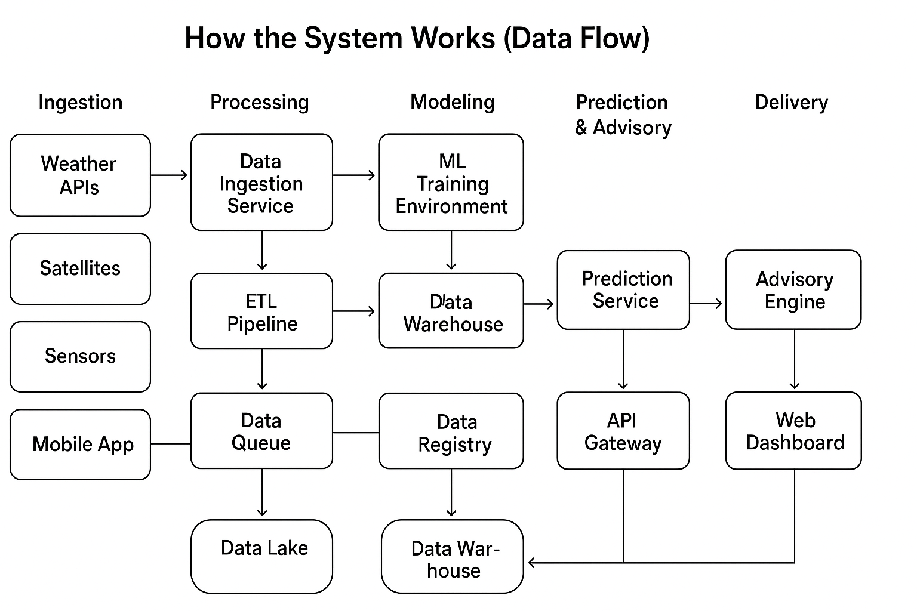

**2.7 DFD Level 0(Conext-level-DFD)**

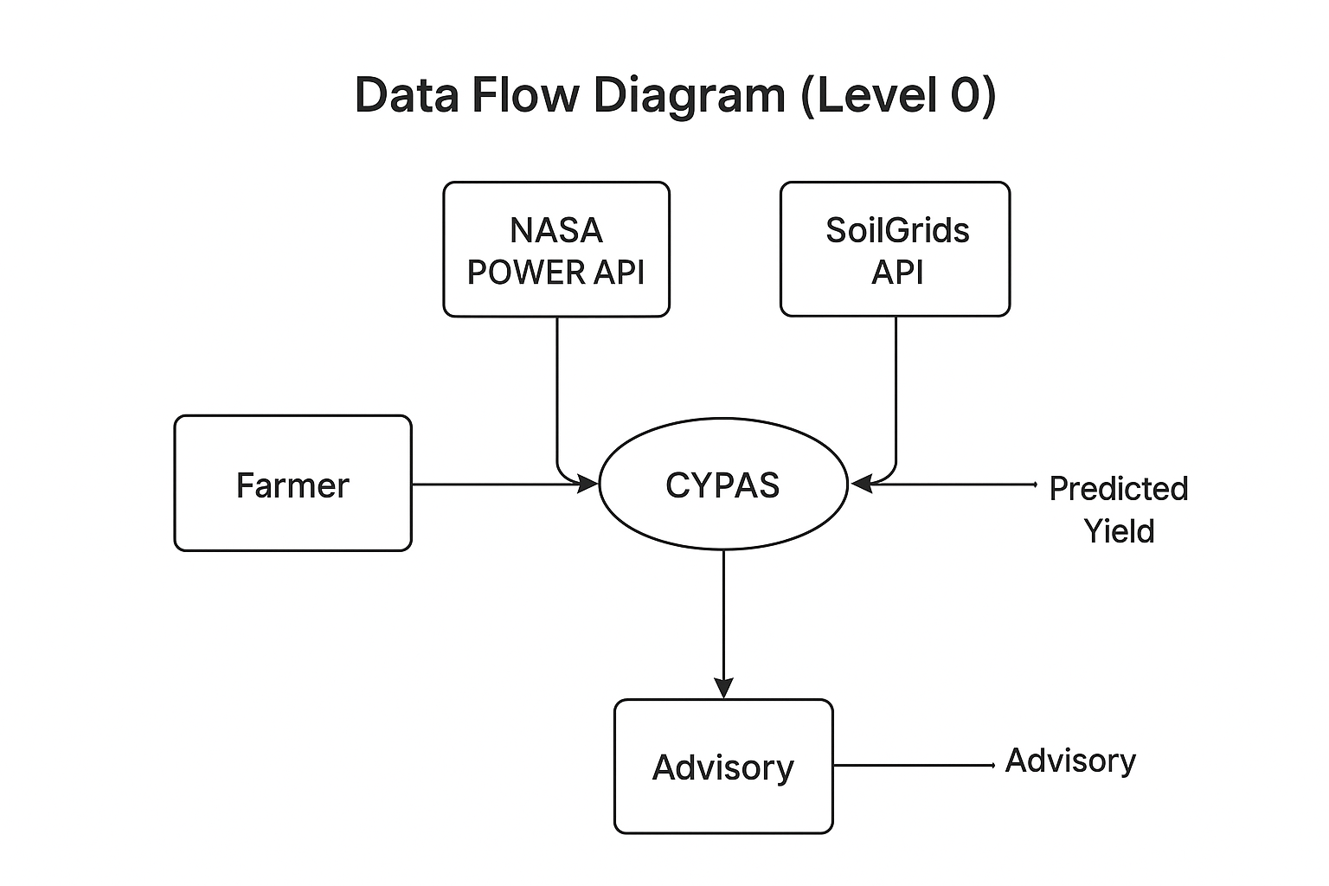

**2.8 DFD Level 1**

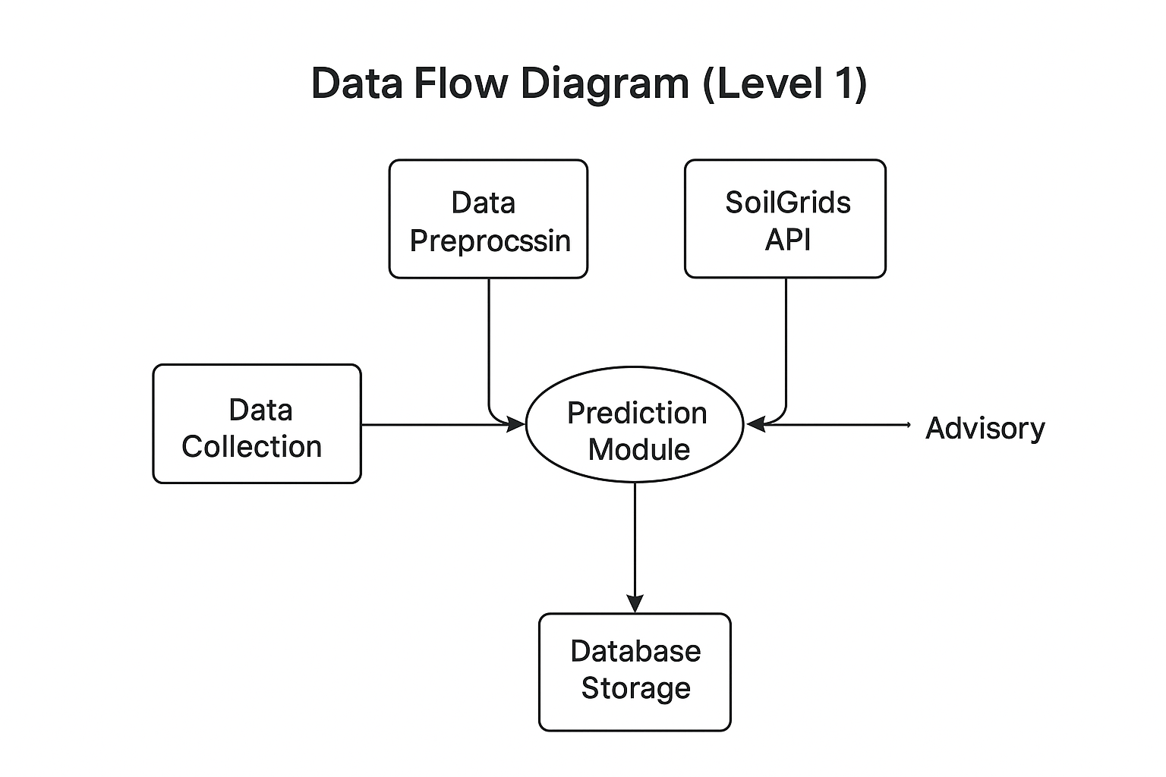

# ****3.0 System Features****

**3.1 Use Case Diagram**

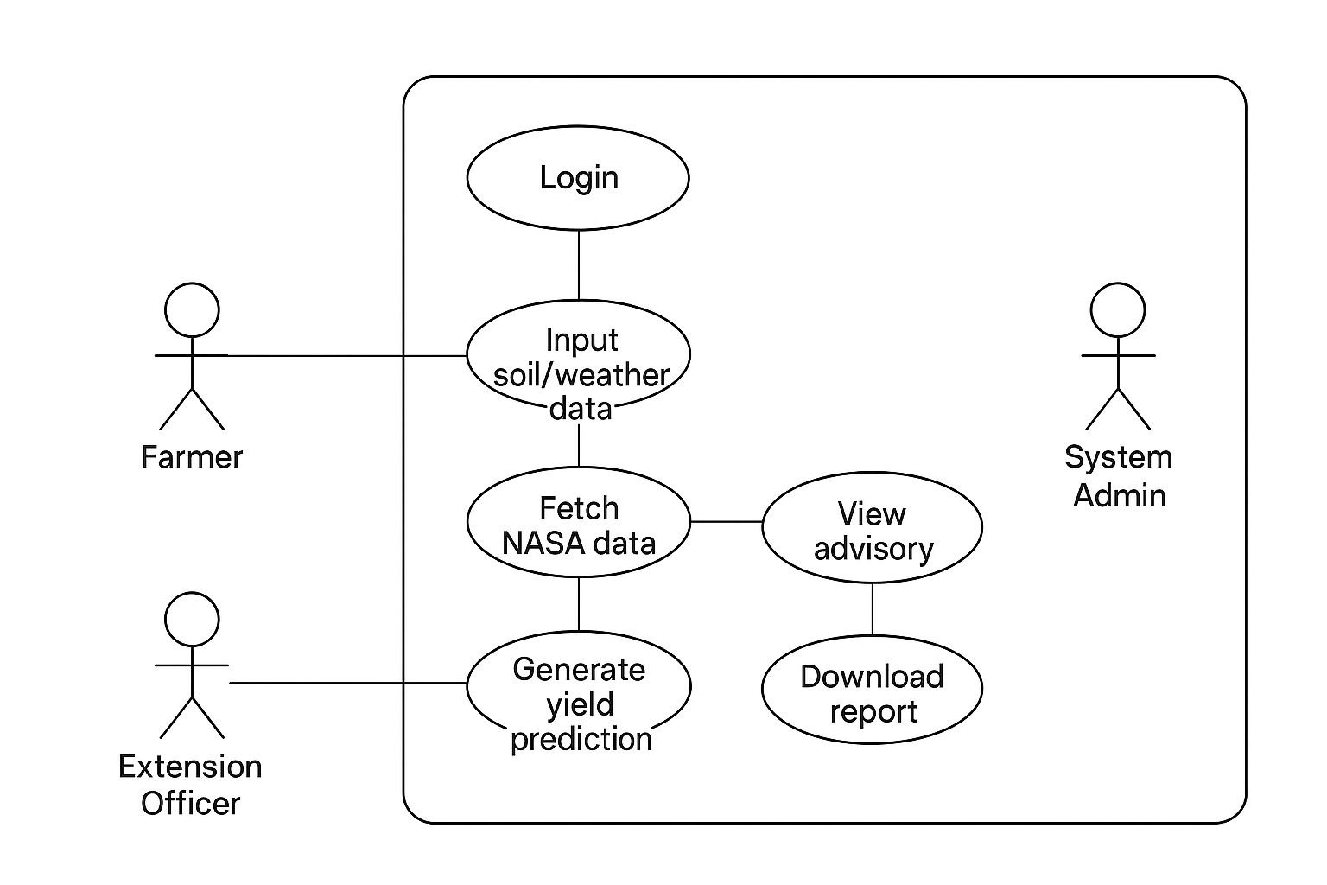

## ****3.1.1 Yield Prediction Feature****

### ****3.1.2 Description****

The Yield Prediction feature provides field-level maize yield estimates using machine learning models trained on soil data, weather patterns, agronomic practices, and historical yield trends. The objective is to support data-driven planning, reduce uncertainty, and guide farmers toward improved management decisions.

### ****3.1.3 Functional Requirements****

**FR1:** The system shall allow users to input key agronomic parameters (e.g., planting date, seed variety, fertilizer use, soil attributes).

**FR2:** The system shall automatically fetch historical and forecasted weather data relevant to the user’s location.

**FR3:** The machine learning model shall compute a yield prediction in tonnes per hectare (t/ha).

**FR4:** The system shall provide confidence intervals or uncertainty scores associated with each prediction.

**FR5:** The system shall store prediction results for future analysis and reporting.

**FR6:** The system shall generate a brief, user-friendly explanation of factors influencing the predicted yield.

### ****3.1.4 Stimulus/Response Sequence****

| **User Action** | **System Response** |
| --- | --- |
| User enters field data and submits prediction request. | System validates inputs and retrieves required weather data. |
| System processes data through the ML model. | A yield prediction and confidence interval are generated. |
| User views results. | System displays predicted yield, key influencing factors, and option to view advisory guidance. |

### ****3.1.5 Priority****

High Priority — Core computational function of the entire system.

# ****3.2 Advisory Recommendation Feature****

### ****3.2.1 Description****

The Advisory Recommendation feature generates personalized, context-specific agronomic guidance for farmers based on predicted yield, soil conditions, climatic indicators, and best-practice agronomic knowledge. The aim is to translate data insights into actionable farming decisions that improve productivity and reduce risks.

### ****3.2.2 Functional Requirements****

**FR1:** The system shall analyze prediction outputs to identify key limiting factors (e.g., low nitrogen, irregular rainfall).

**FR2:** The system shall generate fertilizer recommendations tailored to soil nutrient status and crop stage.

**FR3:** The system shall provide pest and disease management alerts based on climatic conditions and risk patterns.

**FR4:** The system shall suggest optimal planting windows using weather forecasts.

**FR5:** The system shall offer water management or irrigation guidance if moisture deficits are detected.

**FR6:** Recommendations shall be presented in clear, farmer-friendly language.

**FR7:** The system shall store advisory messages for report generation.

### ****3.2.3 Stimulus/Response Sequence****

| **User Action** | **System Response** |
| --- | --- |
| User retrieves prediction results. | System analyzes drivers and identifies advisory needs. |
| User selects “View Advisory.” | System displays fertilizer, pest, irrigation, and planting recommendations. |
| User downloads or saves the advisory. | Advisory is stored and available offline. |

### ****3.2.4 Priority****

High Priority — Directly supports decision-making and farmer adoption.

# ****3.3 Weather and Climate Data Integration****

### ****3.3.1 Description****

Integrates real-time, historical, and forecast weather data essential for accurate yield prediction and advisory generation.

### ****3.3.2 Functional Requirements****

**FR1:** System shall automatically fetch weather data using GPS coordinates.

**FR2:** System shall store daily rainfall, temperature, and solar radiation data.

**FR3:** System shall generate seasonal summaries (e.g., accumulated rainfall).

**FR4:** System shall detect extreme weather conditions and trigger alerts.

**FR5:** Forecast data shall inform advisory recommendations.

### ****3.3.3 Priority****

High — Climate is a major determinant of yield.

# ****3.4 Soil Profile Management Feature****

### ****3.4.1 Description****

Manages soil test results and soil fertility indicators needed for nutrient recommendations and yield estimation.

### ****3.4.2 Functional Requirements****

**FR1:** System shall allow input of soil pH, N, P, K, and organic carbon.

**FR2:** System shall compute nutrient deficiency scores.

**FR3:** System shall support integration with ISRIC SoilGrids where soil tests are unavailable.

**FR4:** Soil data shall be stored securely for future seasons.

### ****3.4.3 Priority****

Medium–High.

# ****3.5 Report Generation Feature****

### ****3.5.1 Description****

Produces downloadable reports summarizing predictions, advisories, weather trends, and soil diagnostics.

### ****3.5.2 Functional Requirements****

**FR1:** System shall generate PDF reports containing yield predictions and advisories.

**FR2:** Reports shall include graphs, tables, and explanations.

**FR3:** Reports shall be downloadable and shareable via mobile devices.

**FR4:** Reports shall store a timestamp and user ID.

### ****3.5.3 Priority****

Medium.

**3.6 Sequence diagram**

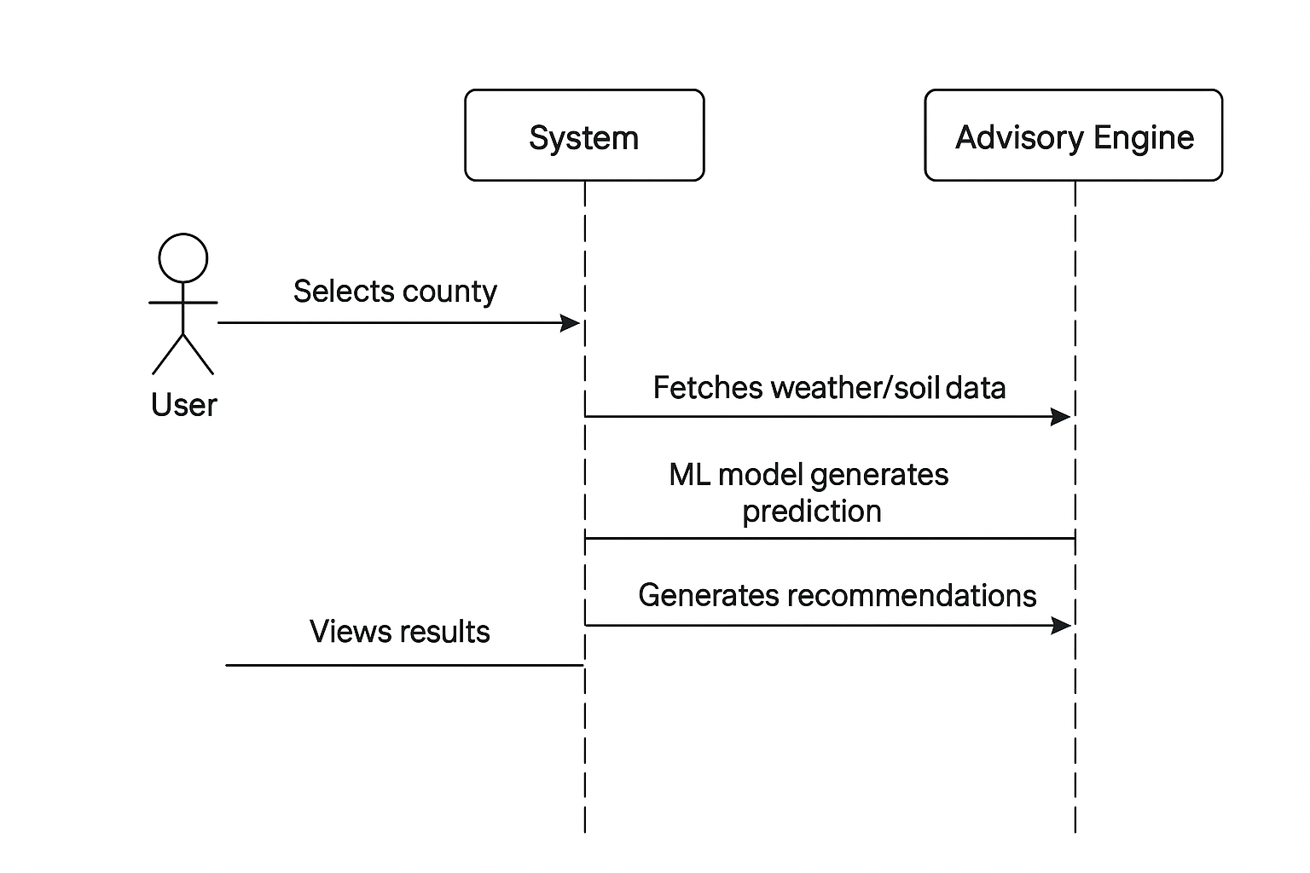

# ****4.0 External Interface Requirements****

# ****4.1 User Interfaces****

Mobile-friendly dashboard for farmers.

Advanced analytics dashboard for extension officers.

Admin panel for model and user management.

Clean visual layout with icons, charts, and multilingual support.

# ****4.2 Hardware Interfaces****

Android smartphones

Tablets for field officers

Cloud/on-premise servers

**4.3 Software Interfaces**

Weather APIs (NASA POWER, CHIRPS, OpenWeatherMap)

Soil databases (ISRIC SoilGrids)

Optional satellite data APIs

Database management system (PostgreSQL/MySQL)

# ****4.4 Communication Interfaces****

HTTPS for secure communication

REST APIs between modules

JSON format for all data exchange

Offline caching mechanisms for low-connectivity zones

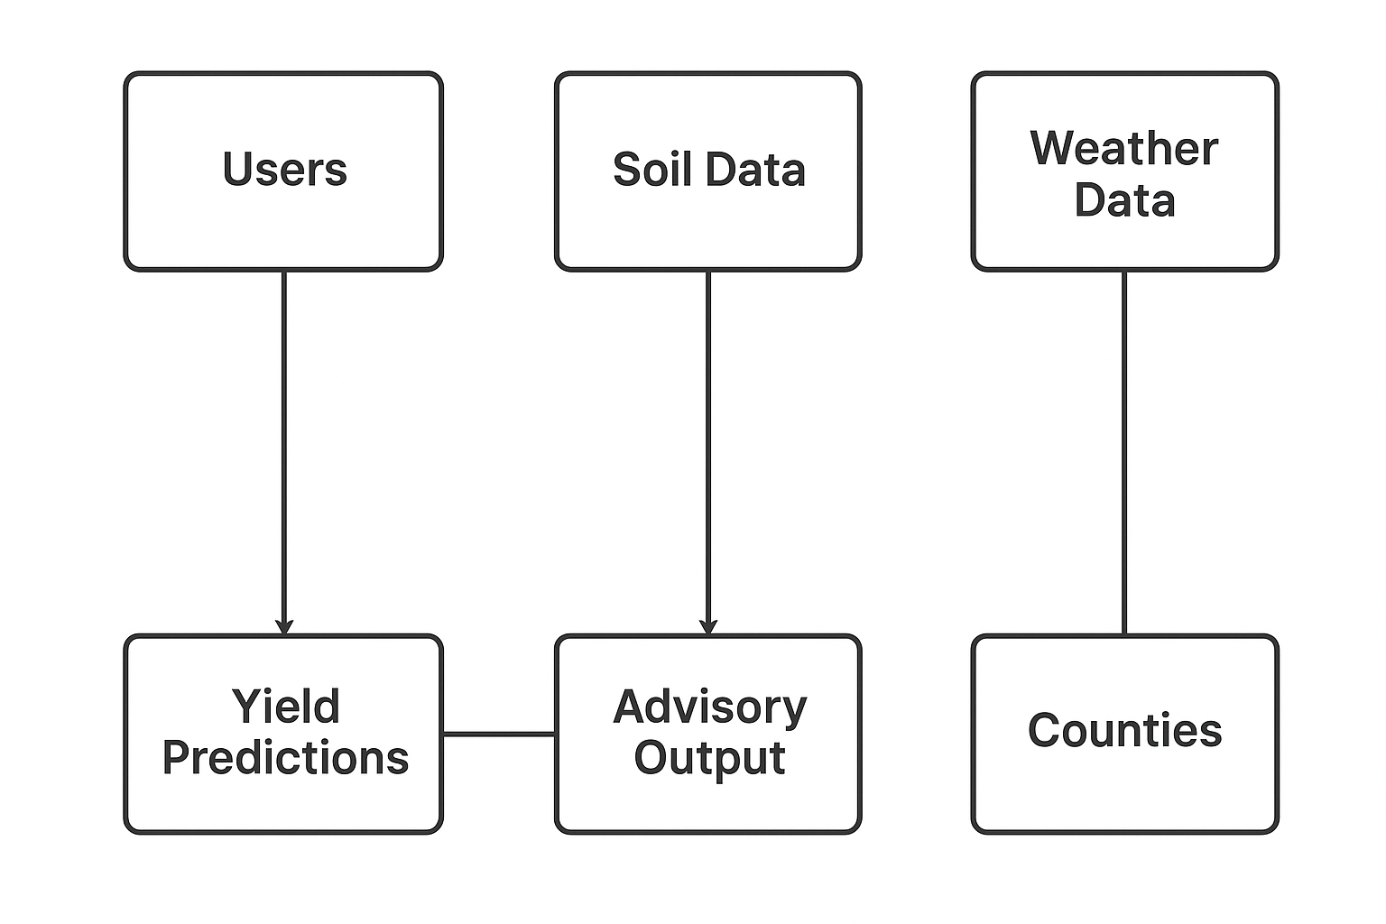

# ****5.0 Non-Functional Requirements****

## ****5.1 Performance Requirements****

Prediction generation ≤ 5 seconds

System uptime ≥ 99%

Supports up to 1,000 concurrent users gracefully

## ****5.2 Safety Requirements****

Clear user disclaimers to avoid misinterpreting predictive outputs

Advisory content must follow agronomic best practices

Data backups to prevent loss

## ****5.3 Security Requirements****

Compliance with Kenya Data Protection Act (2019)

Data encryption at rest and in transit

Secure authentication and role-based access control

Audit logs for all system activities

# ****6.0 Other Requirements****

Multilingual support

Offline mode for advisories

Scalable architecture for national deployment

Seasonal model retraining to improve accuracy

User training materials (videos, guides)

# ****7.0 References****

FAO (2022). Climate-Smart Agriculture & Maize Productivity.

ISRIC. SoilGrids Documentation.

NASA POWER API Guide.

CHIRPS Rainfall Data Documentation.

XGBoost & Scikit-Learn ML Framework Documentation.

Kenya Data Protection Act (2019).